General Instructions For All PSP Programming Exercises

Your principal goal should be to turn in work that is correct. Do not turn in incorrect homework. While it is important that you turn in work on time, it is much more important that it be correct.

Your results must be neat and legible, but they need not be typed. You should submit only the deliverables specified, stapled together, and in the order indicated. Concentrate on providing the required materials as quickly and as efficiently as you can. You will need all your PSP data for subsequent assignments, so you should retain a complete copy of everything you submit.

It is perfectly acceptable for you to get help from your classmates and associates. The ground rules for getting such assistance are as follows:

- If you have a technical question, you may ask your associates for help. You must also record the point in the process where you got this assistance and the time you and your associates spent on the question.

- You must make your own conceptual design, size estimates, and resource estimates. Once you have completed them, you may ask that your associates review and comment on them. You may also change your estimates as a result of the reviews. If you do, submit a copy of the original estimate together with the revised one. You must also record the point in the process where you got the assistance, and the time you and your associates spent in this review.

- You must design the program yourself, but you may ask your associates to review your design when you are through. You may change the design as a result of the review, and you must record all defects found in the defect log, noting that they were found during this peer review. You must also record the time you and your associates spent in this review.

- You must produce the source code for the program yourself, but you may ask your associates to review your code when you are through. You may change the code as a result of the review, and you must record all defects found in the defect log, noting that they were found during this peer review. You must also record the time you and your associates spent in this review.

- You are expected to compile and test the program yourself; however, you may ask for your associate’s assistance where needed. You must also record the defects found, the point in the process where you got this assistance, and the time you and your associates spent on this process.

While there is nothing wrong with getting help, it does take time. You should monitor the amount of help you get to ensure the results are worth the time.

PSP Program 5A

General Instructions

Use the PSP1 to accomplish this program. Submit in class, on or before the deadline specified in the course syllabus, the following documents in the following order.

- PSP1.1 Project Plan Summary
- Test Report Template
- PIP forms, including a brief summary of lessons learned
- Size Estimating Template
- Task Planning Template
- Schedule Planning Template
- Time Recording Log
- Defect Recording Log
- Source program listing

Program Requirements

Write a program to numerically integrate a function using Simpson’s rule and write the function for the normal distribution. The program should be designed to integrate using various supplied functions. This rule and several example calculations are given in Section A5 of (Humphrey, 1995). A calculation procedure for this rule is shown in Table A14 of (Humphrey, 1995), reproduced below. (You will need this program to calculate the values of the various statistical distributions used in later program assignments and in the analysis of your PSP data. This program is used in several subsequent exercises where programs are used to calculate the values of the normal distribution, the t distribution, and the χ² distribution.)

Program Testing

Thoroughly test the program. Include a test to calculate the probability values of the normal distribution integral from −∞ to x=2.5, from −∞ to x=0.2, and from −∞ to x=−1.1. The results should be approximately 0.9938, 0.5793, and 0.1357, respectively. Include in your test report a table of results in the format in Table D10 of (Humphrey, 1995), reproduced below.

Table D10. Test Results Format – Program 5A

Test Value – x | Expected Results | Actual Results
2.5 | 0. 9938
0.2 | 0.5793
-1.1 | 0.1357

Simpson’s Rule Calculation Procedure

Purpose | To evaluate the integral of a known function F(x) between two given points.
Conditions | - F(x) must return a finite value for all x values in the integration range.  - F(x) may be computable from a formula or obtainable from a table look-up mechanism.
Inputs and parameters | - x_{low}, x_{high}: real – the integration limits  - E: real – the acceptable error of the result  - N: int – the number of segments in the integration  - OldResult = 0: real – the previous answer  - Result: real – the answer
Steps | 1. Identify the upper and lower limits of the numerical integration.  2. Select the initial number of segments, N, an even number  3. Divide the range, x_{high} – x_{low}, into N segments of width W:  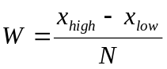  4. Compute the integral value with the following equation:  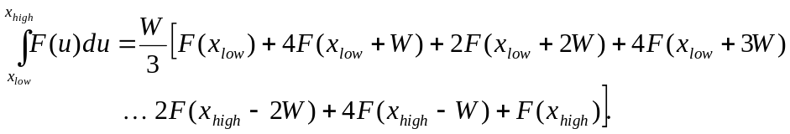  5. Compare the result:  if abs(Result - OldResult) <= E  return Result  else continue  6. Adjust the new parameter values:  OldResult = Result;  N=2*N  7. Recycle at step 3.

Example: Integrating the Normal Distribution using Simpson’s Rule

To calculate the value of the normal distribution for one case, say x = -1.1:

- Note from the equation of the normal distribution
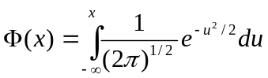
that the integral is from -∞ to -1.1. Note that the general rule for integrating from -∞ to x is the following:
For positive values of x, integrate from 0 to x and add the result to 0.5 (Φ(0.0)=0.5) to get the answer.
For negative values of x, integrate from 0 to the absolute value of x and subtract the result from 0.5 to get the answer.
Thus, using the above rule of integrating negative values of x, pick x_{low}=0 and x_{high}=1.1. You will later subtract the integration result from 0.5 to get the answer.
- Select an initial number N. For this example, N=20. While larger numbers may be needed to get an accurate result, a low initial value is often helpful in debugging programs. Thus one may even want to start with N=10, for example.
- Divide the range from 0 to 1.1 by 20 to give an initial segment width of W=0.055.
- Calculate the integral value using Simpson’s rule. The sum, 0.364332, is obtained by summing the values of each of the 21 terms in the equation, as illustrated in the table below.

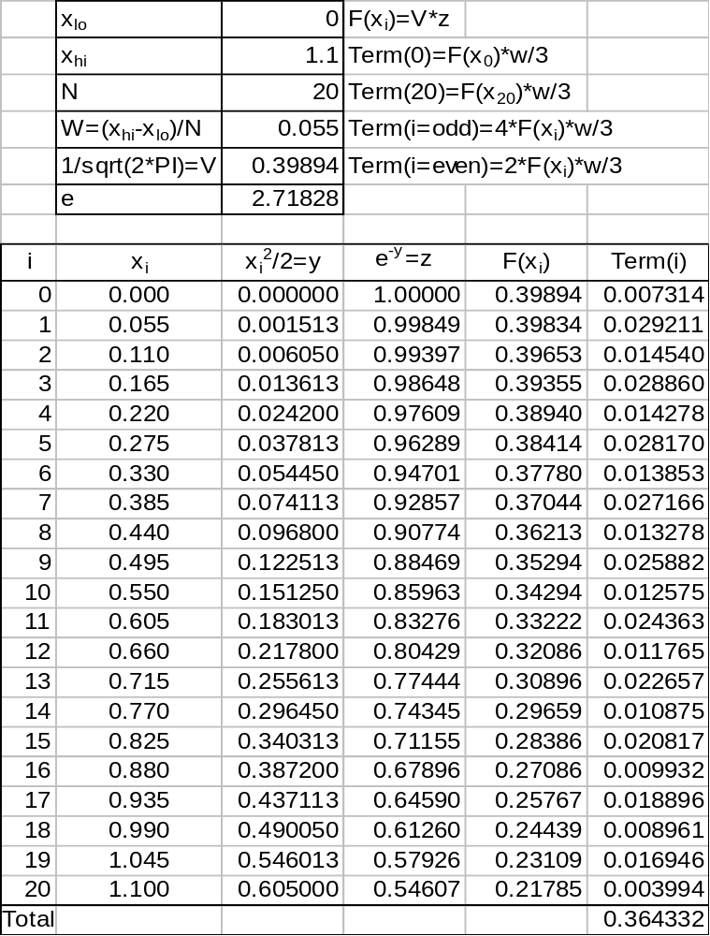

- Compare this result with the value obtained in the previous iteration and compute the error (Result-OldResult). If this error is larger than the permissible value E, continue the integration to improve its accuracy. Since this was the first pass, the value of OldResult was initialized to 0, so error equals Result. This error is larger than the permissible error value, so iterate again. Note that in the next iteration, with N=40, the result will be 0.346332, and the error will be zero. If after the first trial, the absolute value of the error were larger than E, iterate again.
- Double N. The example here started with N=20 so the second cycle would be with N=40.
- Repeat the calculations starting at step 3.

Note that when done, there still is a need to adjust the value obtained using Simpson’s rule to account for the fact that the integral was from x_{low}=0 instead of from x_{low}=-∞. In this case, adjust by subtracting this value from 0.5 giving a final result of 0.135668. Because the value of the normal distribution for -1.1 is 0.1357, clearly N=20 already gives a very accurate result. Note that with 40 terms, the result is 0.135668, which is the same as the value with 20 terms.

